Weekly COVID Report, United States

Table of contents

library(tidyverse)  
library(flextable)  
library(gt)  
library(gtExtras)  
devtools::load_all()  
theme_set(theme_classic())

case_death_nat_tbl <- get_case_death_nat_tbl(username = params$username)  
  
cases_nat_tbl <- case_death_nat_tbl |>   
 select(!contains("deaths"))  
  
deaths_nat_tbl <- case_death_nat_tbl |>   
 select(!contains("cases"))  
  
case_death_jur_tbl <- get_case_death_juris_tbl(username = params$username) |>   
 mutate(cases_date = lubridate::ymd(cases_date))  
  
hosp_nat_tbl <- get_hosp_nat_tbl(username = params$username)  
lab_nat_tbl <- get_lab_nat_tbl(username = params$username)

# Weekly Summary, United States

| indicator | cum | new | avg | 7cum | change |
| --- | --- | --- | --- | --- | --- |
| Cases | 95470430 | 57573 | 57356 | 120.9 | -12.2% |
| Hospital Admissions | 5,306,620 | 3411 | 4104 | 8.7 | -10.2% |
| Deaths | 1048148 | 328 | 365 | 0.8 | 2.8% |
| Test Volume | 956,233,878 | N/A | 436,678 | 788.0 | -10.6% |
| Test Positivity | 9.5% | N/A | 10.8% | N/A | -10.9% |

# US Cases and Deaths by Jurisdiction

case_death_jur_tbl |>  
 mutate(date = cases_date) |>   
 filter(date >= max(date)-30) |>   
 arrange(date) |>   
 group_by(juris) |>   
 summarise(cases_trend = list(cases_new),  
 deaths_trend = list(deaths_new),  
 cases_cum = cases_cum[which.max(date)],  
 cases_new = cases_new[which.max(date)],  
 cases_avg = cases_avg[which.max(date)],  
 cases_avg_per_100k = cases_avg_per_100k[which.max(date)],  
 deaths_cum = deaths_cum[which.max(date)],  
 deaths_new = deaths_new[which.max(date)],  
 deaths_avg = deaths_avg[which.max(date)],  
 deaths_avg_per_100k = deaths_avg_per_100k[which.max(date)],  
 .groups = "drop"  
 ) |>   
 relocate(cases_trend, .after = cases_new) |>   
 relocate(deaths_trend, .after = deaths_new) |>   
 gt() |>   
 fmt_integer(columns = c("cases_cum",  
 "cases_new",  
 "cases_avg",  
 "deaths_cum",  
 "deaths_new",  
 "deaths_avg")) |>   
 fmt_number(columns = c("cases_avg_per_100k",  
 "deaths_avg_per_100k"),  
 decimals = 1) |>   
 gt_plt_sparkline(deaths_trend,  
 palette = c("black",  
 "black",  
 "black",  
 "red",  
 "lightgrey"),  
 fig_dim = c(15,20),  
 same_limit = FALSE,  
 label = FALSE) |>   
 gt_plt_sparkline(cases_trend,  
 palette = c("black",  
 "black",  
 "black",  
 "red",  
 "lightgrey"),  
 fig_dim = c(15,20),  
 same_limit = FALSE,  
 label = FALSE) |>  
 gt_color_rows(columns = c("cases_avg_per_100k","deaths_avg_per_100k"))|>   
 gt_color_rows(columns = c("cases_avg","deaths_avg"), palette = "ggsci::green_material") |>   
 tab_spanner("Cases",   
 columns = c("cases_cum",  
 "cases_new",   
 "cases_trend",  
 "cases_avg",  
 "cases_avg_per_100k")) |>   
 tab_spanner("Deaths",   
 columns = c("deaths_cum",  
 "deaths_new",   
 "deaths_trend",  
 "deaths_avg",  
 "deaths_avg_per_100k")) |>   
 cols_label(juris = "Jurisdiction",  
 cases_cum = "Total",  
 cases_new = "New",  
 cases_avg = "7-Day Avg",  
 cases_avg_per_100k = "Avg per 100k",  
 cases_trend = "New - 30 Days",  
 deaths_cum = "Total",  
 deaths_new = "New",  
 deaths_avg = "7-Day Avg",  
 deaths_avg_per_100k = "Avg per 100k",  
 deaths_trend = "New - 30 Days") |>   
 gt_theme_espn()

| Jurisdiction | Cases | | | | | Deaths | | | | |
| --- | --- | --- | --- | --- | --- | --- | --- | --- | --- | --- |
| Total | New | New - 30 Days | 7-Day Avg | Avg per 100k | Total | New | New - 30 Days | 7-Day Avg | Avg per 100k |
| AK | 281,727 | 0 |  | 137 | 18.7 | 1,329 | 0 |  | 4 | 0.5 |
| AL | 1,514,077 | 918 |  | 958 | 19.5 | 20,345 | 20 |  | 4 | 0.1 |
| AR | 945,449 | 660 |  | 680 | 22.5 | 11,983 | 6 |  | 4 | 0.1 |
| AS | 8,217 | 0 |  | 0 | 0.0 | 34 | 0 |  | 0 | 0.0 |
| AZ | 2,264,159 | 0 |  | 874 | 12.0 | 31,244 | 0 |  | 12 | 0.2 |
| CA | 11,184,654 | 3,861 |  | 4,109 | 10.4 | 94,747 | 0 |  | 27 | 0.1 |
| CNMI | 13,155 | 0 |  | 1 | 1.9 | 40 | 0 |  | 0 | 0.0 |
| CO | 1,645,456 | 586 |  | 621 | 10.8 | 13,240 | 4 |  | 5 | 0.1 |
| CT | 887,501 | 1,153 |  | 985 | 27.6 | 11,330 | 1 |  | 4 | 0.1 |
| DC | 167,489 | 69 |  | 85 | 12.0 | 1,382 | 0 |  | 0 | 0.0 |
| DE | 305,772 | 255 |  | 197 | 20.2 | 3,086 | 6 |  | 1 | 0.1 |
| FL | 7,091,887 | 2,657 |  | 3,071 | 14.3 | 80,861 | 0 |  | 9 | 0.0 |
| FSM | 10,010 | 0 |  | 91 | 88.9 | 30 | 0 |  | 0 | 0.0 |
| GA | 2,893,001 | 0 |  | 1,383 | 13.0 | 40,025 | 0 |  | 21 | 0.2 |
| GU | 58,370 | 0 |  | 21 | 12.5 | 394 | 0 |  | 0 | 0.0 |
| HI | 333,547 | 0 |  | 181 | 12.8 | 1,653 | 0 |  | 1 | 0.1 |
| IA | 852,206 | 973 |  | 485 | 15.4 | 9,994 | 0 |  | 4 | 0.1 |
| ID | 493,071 | 491 |  | 215 | 12.0 | 5,156 | 14 |  | 4 | 0.2 |
| IL | 3,733,902 | 2,492 |  | 2,512 | 19.8 | 39,536 | 12 |  | 13 | 0.1 |
| IN | 1,914,351 | 1,788 |  | 861 | 12.8 | 24,605 | 24 |  | 8 | 0.1 |
| KS | 873,075 | 0 |  | 595 | 20.4 | 9,072 | 0 |  | 1 | 0.0 |
| KY | 1,566,265 | 2,174 |  | 1,327 | 29.7 | 16,902 | 16 |  | 6 | 0.1 |
| LA | 1,448,503 | 689 |  | 803 | 17.3 | 17,977 | 9 |  | 8 | 0.2 |
| MA | 2,030,335 | 0 |  | 1,286 | 18.7 | 21,588 | 0 |  | 7 | 0.1 |
| MD | 1,239,719 | 984 |  | 947 | 15.7 | 15,301 | 0 |  | 6 | 0.1 |
| ME | 286,569 | 190 |  | 241 | 17.9 | 2,566 | 2 |  | 2 | 0.1 |
| MI | 2,804,588 | 0 |  | 2,625 | 26.3 | 38,317 | 0 |  | 28 | 0.3 |
| MN | 1,651,999 | 0 |  | 907 | 16.1 | 13,558 | 0 |  | 7 | 0.1 |
| MO | 1,637,503 | 9,185 |  | 1,312 | 21.4 | 21,421 | 46 |  | 7 | 0.1 |
| MS | 922,493 | 0 |  | 517 | 17.4 | 12,853 | 0 |  | 5 | 0.2 |
| MT | 308,023 | 1,314 |  | 188 | 17.6 | 3,512 | 3 |  | 0 | 0.0 |
| NC | 3,165,186 | 0 |  | 1,480 | 14.1 | 26,417 | 0 |  | 1 | 0.0 |
| ND | 267,287 | 0 |  | 145 | 19.0 | 2,364 | 0 |  | 1 | 0.1 |
| NE | 534,818 | 0 |  | 253 | 13.1 | 4,490 | 0 |  | 0 | 0.0 |
| NH | 347,209 | 0 |  | 205 | 15.1 | 2,682 | 0 |  | 2 | 0.1 |
| NJ | 2,708,594 | 2,487 |  | 2,078 | 23.4 | 34,663 | 5 |  | 6 | 0.1 |
| NM | 615,598 | 193 |  | 243 | 11.6 | 8,515 | 6 |  | 5 | 0.2 |
| NV | 845,879 | 388 |  | 264 | 8.6 | 11,445 | 7 |  | 3 | 0.1 |
| NYC | 2,845,390 | 0 |  | 1,925 | 22.9 | 41,791 | 0 |  | 14 | 0.2 |
| NYX | 3,197,491 | 5,583 |  | 2,336 | 21.1 | 28,990 | 20 |  | 11 | 0.1 |
| OH | 3,117,109 | 0 |  | 2,936 | 25.1 | 39,675 | 0 |  | 14 | 0.1 |
| OK | 1,190,969 | 1,776 |  | 901 | 22.8 | 14,784 | 0 |  | 3 | 0.1 |
| OR | 885,963 | 0 |  | 371 | 8.8 | 8,492 | 0 |  | 3 | 0.1 |
| PA | 3,220,317 | 0 |  | 2,501 | 19.5 | 46,970 | 0 |  | 20 | 0.2 |
| PR | 946,966 | 1,133 |  | 1,249 | 39.1 | 5,066 | 3 |  | 5 | 0.2 |
| PW | 5,445 | 15 |  | 2 | 9.3 | 6 | 0 |  | 0 | 0.0 |
| RI | 401,224 | 0 |  | 212 | 20.0 | 3,661 | 0 |  | 1 | 0.1 |
| RMI | 15,213 | 0 |  | 12 | 15.4 | 17 | 0 |  | 0 | 0.0 |
| SC | 1,696,746 | 0 |  | 552 | 10.7 | 18,316 | 0 |  | 0 | 0.0 |
| SD | 259,683 | 0 |  | 168 | 19.0 | 3,014 | 0 |  | 2 | 0.2 |
| TN | 2,325,996 | 1,338 |  | 1,329 | 19.5 | 27,626 | 41 |  | 13 | 0.2 |
| TX | 7,827,704 | 10,793 |  | 5,171 | 17.8 | 88,954 | 56 |  | 20 | 0.1 |
| USVI | 23,049 | 18 |  | 18 | 16.9 | 123 | 0 |  | 0 | 0.0 |
| UT | 1,034,616 | 0 |  | 355 | 11.1 | 5,001 | 0 |  | 2 | 0.1 |
| VA | 2,070,182 | 0 |  | 1,370 | 16.1 | 21,679 | 0 |  | 10 | 0.1 |
| VT | 131,257 | 74 |  | 73 | 11.7 | 685 | 0 |  | 1 | 0.2 |
| WA | 1,800,790 | 1,314 |  | 1,033 | 13.6 | 14,199 | 15 |  | 14 | 0.2 |
| WI | 1,851,886 | 1,333 |  | 1,234 | 21.2 | 15,190 | 5 |  | 10 | 0.2 |
| WV | 595,044 | 689 |  | 658 | 36.7 | 7,364 | 7 |  | 6 | 0.3 |
| WY | 175,746 | 0 |  | 65 | 11.2 | 1,888 | 0 |  | 1 | 0.2 |

## Weekly Change in COVID-19 Cases, United States

plot_epi_curve(cases_nat_tbl, params$timeframe, "#440154FF")

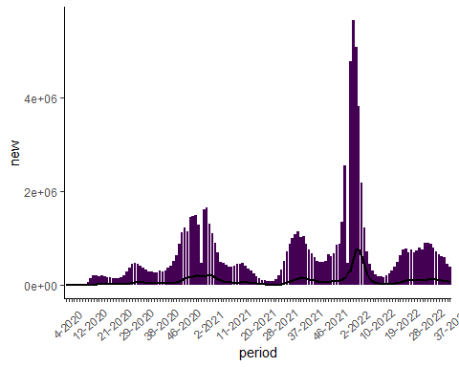

### Weekly Change in COVID-19 Hospital Admissions, United States

plot_epi_curve(hosp_nat_tbl, params$timeframe, "#f27f27")

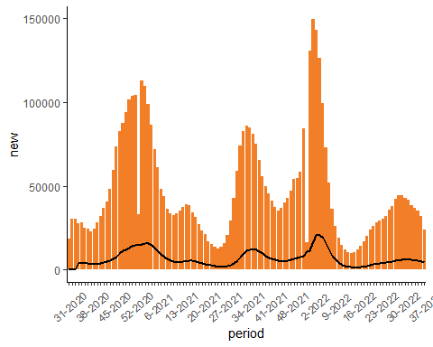

### Weekly Change in COVID-19 Deaths, United States

plot_epi_curve(deaths_nat_tbl, params$timeframe, "#31688EFF")

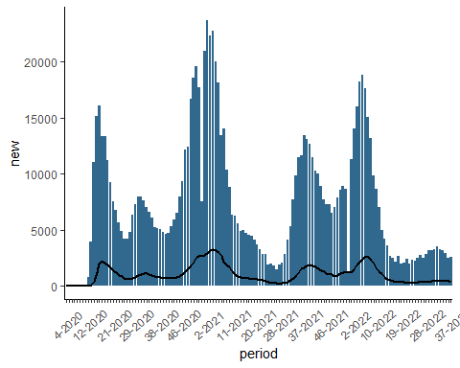

### Weekly Change in COVID-19 Testing, United States

plot_epi_curve(lab_nat_tbl, params$timeframe, "#e3de42")

